

April 3, 2020
Indiana Invasives Initiative T-shirt Campaign
Invasive plants negatively impact Indiana in many ways, including loss of biodiversity, degradation of natural habitats, decreased property values, declining agricultural yields, & adverse effects on public utilities, recreation and tourism. Indiana landowners and managers spend millions annually managing invasive plants throughout the state.
Order your Indiana Invasives Initiative T-shirt today and help us spread the word about how invasive plants diminish the natural beauty and productivity of Indiana! All proceeds and donations go to SICIM in support of the Indiana Invasives Initiative.
On the front of the shirt, the welcoming phrase "Ask Me About Invasive Plants" is a great way to start a conversation and raise awareness. The illustrations on the back depict 3 common invasive plant threats to Indiana (garlic mustard, Asian bush honeysuckle, and Callery pear) with the names of 10 "Most Unwanted Invasive Plants" listed below.
The Indiana Invasives Initiative is a partnership between Southern Indiana Cooperative Invasives Management (SICIM) & the USDA Natural Resource Conservation Service (NRCS) to manage invasive plants and raise public awareness. The Indiana Invasives Initiative collaborates with local partners in every county to develop sustainable Cooperative Invasive Species Management Areas (CISMAs) to build capacity for the health of our lands and waters across the state.
Order online at: https://www.bonfire.com/indianinvasivesinitiative/
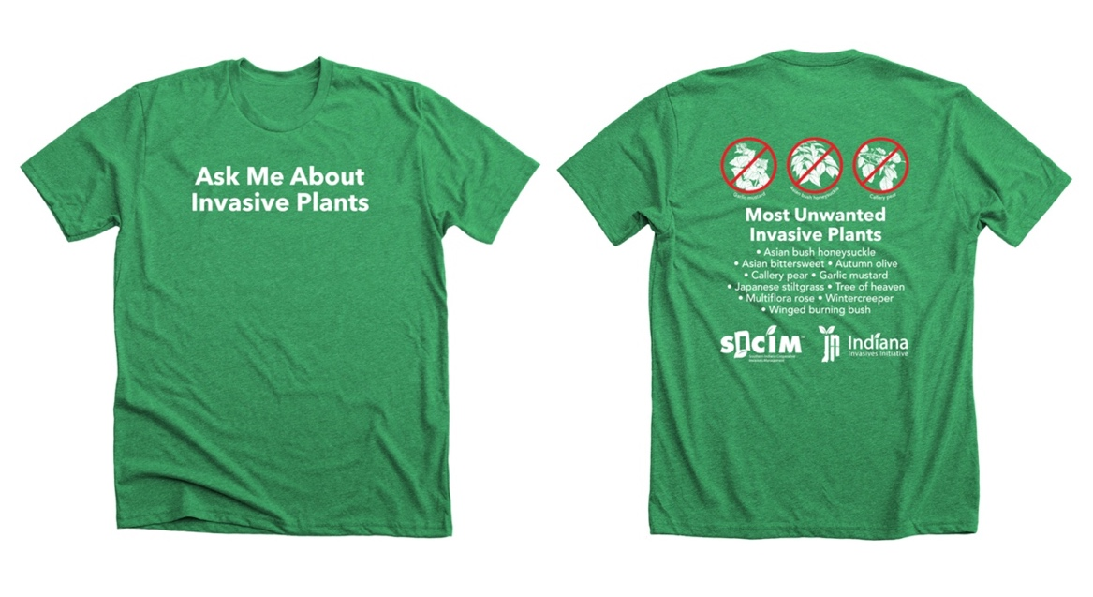
Visit us at www.sicim.info for more information.

